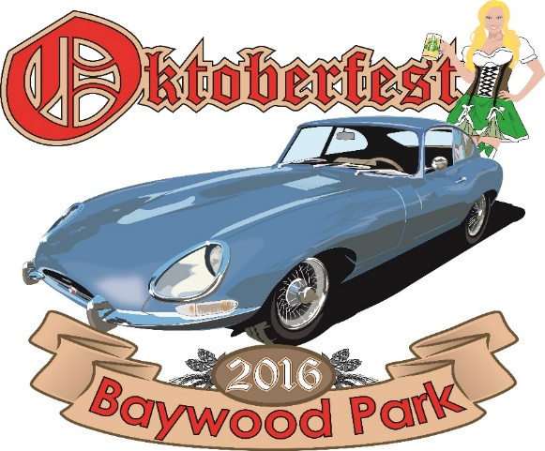
11th ANNUAL CAR SHOW BY THE BAY
SUNDAY October 30th, 2016
Registration 7am, show 8:00-5:00
The Los Osos/Baywood Park Chamber of Commerce, Bay-Osos Kiwanis Club and Bear Metal Kustoms are pleased to announce the annual Oktoberfest Car Show to be held in Baywood Park on Sunday, October 30th.
The Car Show parking will be on 2nd st, on the main drag between Santa Maria Ave and Santa Ysabel. PLEASE ENTER CAR SHOW AT THE CORNER OF SANTA YSABEL AND 2ND ST.
We appreciate your participation in this first-class event. Proceeds from this event are used for the car show itself, funding the Visitor center and help with local school donations and scholarships.
If you have any car show questions, contact Jason Pall at Bear Metal Kustoms: 805-772-7767
Jason Pall, Chairperson, 2016 Oktoberfest & Car Show by the Bay
11th ANNUAL CAR SHOW BY THE BAY
ENTRY FEE: $35 FOR EACH VEHICLE. Includes Dash Plaque. Please make check payable to:
Los Osos Chamber of Commerce
NAME:__________________________________________________________________________________
ADDRESS:______________________________________________________________________________
VEHICLE YEAR:_________________MAKE:____________________PHONE:______________________
I hereby release the event sponsors—Los Osos/Baywood Chamber of Commerce, Bay-Osos Kiwanis, Bear Metal Kustoms as well as their members and affiliates, of all liability for any harm or damage to my person or property.
SIGNATURE:__________________________________________________DATE:____________________
Mail Entry form and checks to : Bear Metal Kustoms 1147 Scott st Morro Bay CA 93442

